

Simon Chaisouang

[shchaiso@uark.edu](mailto:shchaiso@uark.edu)

010878218

CSCE 5613 Artificial Intelligence

Spring 2025

Late Days: 3

## 1 – Image Classification

**Introduction**

For this section we will study a pretrained model (ResNet) to classify objects of various images.

|  |  |
| --- | --- |
|  |  |
|  |  |
|  |  |
|  |  |
|  |  |

**Table 1. Table of 10 Classified Objects**

We refer to the following results below for top 5 predictions of the 10 images using ResNet-101 and DenseNet121:

|  |  |
| --- | --- |
| ResNet-101 | |
| Class: sports car, sport car. Probability: 42.49%  Class: beach wagon, station wagon, wagon, estate car, beach waggon, station waggon, waggon. Probability: 22.89%  Class: grille, radiator grille. Probability: 12.41%  Class: racer, race car, racing car. Probability: 9.60%  Class: car wheel. Probability: 7.99% | Class: pomegranate. Probability: 34.41%  Class: nail. Probability: 13.04%  Class: Granny Smith. Probability: 9.08%  Class: orange. Probability: 7.04%  Class: croquet ball. Probability: 5.13% |
| Class: soccer ball. Probability: 99.67%  Class: golf ball. Probability: 0.08%  Class: volleyball. Probability: 0.06%  Class: rugby ball. Probability: 0.04%  Class: football helmet. Probability: 0.01% | Class: goose. Probability: 13.72%  Class: ptarmigan. Probability: 9.30%  Class: prairie chicken, prairie grouse, prairie fowl. Probability: 7.98%  Class: quail. Probability: 7.52%  Class: bulbul. Probability: 6.98% |
| Class: folding chair. Probability: 37.53%  Class: dining table, board. Probability: 11.97%  Class: rocking chair, rocker. Probability: 11.55%  Class: studio couch, day bed. Probability: 6.64%  Class: desk. Probability: 4.54% | Class: tabby, tabby cat. Probability: 79.86%  Class: tiger cat. Probability: 16.55%  Class: Egyptian cat. Probability: 1.94%  Class: mouse, computer mouse. Probability: 0.27%  Class: computer keyboard, keypad. Probability: 0.15% |
| Class: jellyfish. Probability: 31.76%  Class: lakeside, lakeshore. Probability: 13.55%  Class: bubble. Probability: 8.51%  Class: eggnog. Probability: 4.50%  Class: plastic bag. Probability: 3.79% | Class: lakeside, lakeshore. Probability: 22.62%  Class: golf ball. Probability: 21.16%  Class: worm fence, snake fence, snake-rail fence, Virginia fence. Probability: 7.31%  Class: rapeseed. Probability: 4.89%  Class: maze, labyrinth. Probability: 3.45% |
| Class: teddy, teddy bear. Probability: 99.17%  Class: toyshop. Probability: 0.20%  Class: hamper. Probability: 0.06%  Class: wool, woolen, woollen. Probability: 0.06%  Class: pencil box, pencil case. Probability: 0.04% | Class: ice cream, icecream. Probabilty: 60.88%  Class: trifle. Probabilty: 27.20%  Class: bakery, bakeshop, bakehouse. Probabilty: 5.71%  Class: chocolate sauce, chocolate syrup. Probabilty: 3.99%  Class: strawberry. Probabilty: 0.94% |

**Tables 2: Table of Top 5 Predictions for 10 images for ResNet-101**

|  |  |
| --- | --- |
| DenseNet121 | |
| Class: sports car, sport car. Probability: 71.12%  Class: convertible. Probability: 7.54%  Class: racer, race car, racing car. Probability: 6.11%  Class: beach wagon, station wagon, wagon, estate car, beach waggon, station waggon, waggon. Probability: 6.07%  Class: grille, radiator grille. Probability: 3.87% | Class: Granny Smith. Probability: 49.78%  Class: pomegranate. Probability: 16.42%  Class: orange. Probability: 4.54%  Class: fig. Probability: 2.73%  Class: jack-o'-lantern. Probability: 2.28% |
| Class: soccer ball. Probability: 99.90%  Class: golf ball. Probability: 0.04%  Class: rugby ball. Probability: 0.01%  Class: croquet ball. Probability: 0.01%  Class: Sealyham terrier, Sealyham. Probability: 0.01% | Class: American coot, marsh hen, mud hen, water hen, Fulica americana. Probability: 34.13%  Class: king penguin, Aptenodytes patagonica. Probability: 16.09%  Class: goose. Probability: 11.97%  Class: indri, indris, Indri indri, Indri brevicaudatus. Probability: 7.43%  Class: partridge. Probability: 4.94% |
| Class: dining table, board. Probability: 27.75%  Class: folding chair. Probability: 17.91%  Class: desk. Probability: 16.58%  Class: table lamp. Probability: 5.94%  Class: studio couch, day bed. Probability: 4.76% | Class: tabby, tabby cat. Probability: 60.10%  Class: tiger cat. Probability: 27.22%  Class: Egyptian cat. Probability: 5.91%  Class: Persian cat. Probability: 0.51%  Class: lynx, catamount. Probability: 0.37% |
| Class: jellyfish. Probability: 35.13%  Class: water tower. Probability: 7.29%  Class: electric ray, crampfish, numbfish, torpedo. Probability: 3.62%  Class: radio telescope, radio reflector. Probability: 3.56%  Class: dugong, Dugong dugon. Probability: 2.25% | Class: lakeside, lakeshore. Probability: 22.83%  Class: worm fence, snake fence, snake-rail fence, Virginia fence. Probability: 6.95%  Class: rapeseed. Probability: 4.28%  Class: maze, labyrinth. Probability: 2.90%  Class: flagpole, flagstaff. Probability: 2.15% |
| Class: teddy, teddy bear. Probability: 99.06%  Class: standard poodle. Probability: 0.20%  Class: toyshop. Probability: 0.04%  Class: rocking chair, rocker. Probability: 0.03%  Class: wool, woolen, woollen. Probability: 0.03% | Class: bakery, bakeshop, bakehouse. Probability: 73.64%  Class: ice cream, icecream. Probability: 13.96%  Class: plate. Probability: 4.01%  Class: trifle. Probability: 3.33%  Class: chocolate sauce, chocolate syrup. Probability: 2.12% |

**Tables 3: Table of Top 5 Predictions for 10 images for DenseNet121**

## 2 - Training Image Classification Model

**Introduction**

For this section we designed and trained a 10-class classification model using the CIFAR-10 data set.

**Model**

The ClassificationModel is defined with three linear layers with ReLU activations between each hidden layer. Each CIFAR-10 image is 32x32 pixels with three color channels (RGB), therefore the input size is 3*32*32= 3072. The first layer transforms the image down to a size of 1024 then gets sized down to 512 at the second layer. Lastly, it maps the image to the 10 possible output classes for CIDAR-10.

**Results**

The final accuracy of the model is reported to be 44.61% while the Top 5 accuracy is reported to be 90.81%.

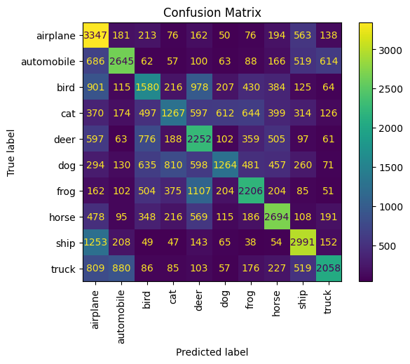

**Image 1: Confusion Matrix of the Testing Results**

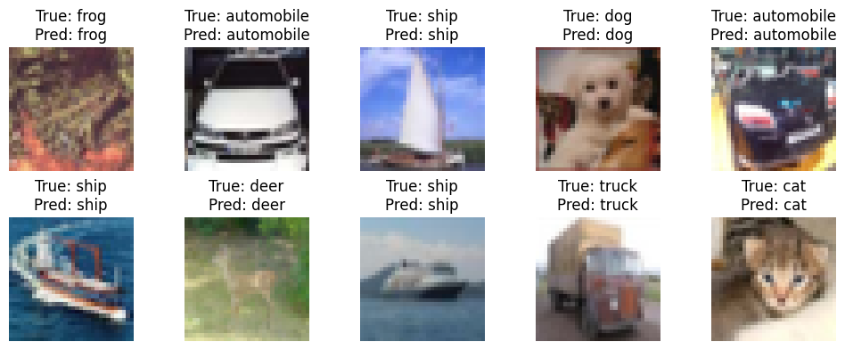

**Image 2: Visualization of 10 Correctly Predicted Samples**